DLC50: International Conference on Discotic Liquid Crystals
50 Years of Molecular Ordering and Innovation (1977–2027) | 16–19 September 2027
Department of Chemistry, Indian Institute of Technology Guwahati, Assam, India

[Insert Concise and Descriptive Title of Your Research Paper Here]
First Author¹*, Second Author², and Third Author¹
¹ Department of Chemistry, Indian Institute of Technology Guwahati, Guwahati, Assam 781039, India
² Department of Materials Science, Indian Institute of Science, Bangalore, Karnataka 560012, India
* Email of Corresponding Author: corresponding.author@iitg.ac.in

ABSTRACT
Discotic liquid crystals (DLCs) have attracted significant research interest owing to their unique supramolecular self-assembly into one-dimensional columnar mesophases, enabling efficient charge transport for organic electronics. In this work, we present the design, synthesis, and characterization of a novel family of star-shaped triphenylene-based discotic mesogens functionalized with flexible fluorinated alkoxy side chains. The chemical structures were confirmed via NMR, FTIR, and high-resolution mass spectrometry. The thermal stability and mesomorphic behavior were systematically investigated using differential scanning calorimetry (DSC), polarized optical microscopy (POM), and temperature-dependent X-ray scattering (WAXS/SAXS). The synthesized compounds exhibit broad-temperature columnar hexagonal (Col_{h}) mesophases with low melting transitions and exceptional ambient stability. Photophysical studies demonstrate intense fluorescence emission in both solution and ordered thin-film states, driven by optimized π-π stacking interactions within the central aromatic cores.
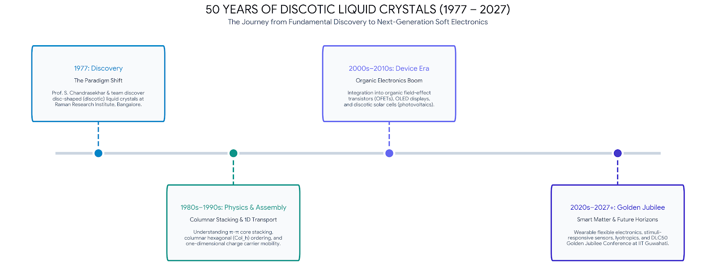
Figure 1: Graphical abstract illustrating the molecular structure, columnar hexagonal (Col_{h}) self-assembly, 1D charge transport pathway.
Keywords: Discotic Liquid Crystals; Supramolecular Self-Assembly; Charge Transport; Organic Electronics
References:
- Chandrasekhar S., Ranganath G. S. Discotic liquid crystals. Rep Prog Phys. 1990;53(1):57–84.
- Iino H., Hanna J., Haarer D. Electronic and ionic carrier transport in discotic liquid crystalline photoconductor. Phys Rev B. 2005;72(19):193203.

GUIDELINES & INSTRUCTIONS FOR ABSTRACT SUBMISSION
• Page Limit & Length: Abstract must fit strictly within 1 page (A4 format). The main abstract text should be between 150 and 200 words.
• Formatting: Use standard Times New Roman font, 14pt for Title (Bold), 12pt for Authors (Bold), 11pt for Affiliations (Italic), 11pt for main text (1.1 line spacing), and 10pt for Figure captions.
• Graphical Abstract: Include max 1 high-resolution schematic diagram or chart (Figure 1) illustrating key molecular structures, schematic, or device data.
• Submission Format: Submit your abstract in Word (.docx) or PDF format through the official portal at https://oes.iitg.ac.in/workshops/dlc50 before the deadline.

